**UNIT-III**

What is the Internet?

Internet is a global network that connects billions of computers across the world with each other and to the World Wide Web. It uses standard internet protocol suite (TCP/IP) to connect billions of computer users worldwide. It is set up by using cables such as optical fibers and other wireless and networking technologies. At present, internet is the fastest mean of sending or exchanging information and data between computers across the world.

## **Why is the Internet Called a Network?**

Internet is called a network as it creates a network by connecting computers and servers across the world using routers, switches and telephone lines, and other communication devices and channels. So, it can be considered a global network of physical cables such as copper telephone wires, fiber optic cables, tv cables, etc. Furthermore, even wireless connections like 3G, 4G, or Wi-Fi make use of these cables to access the Internet.

Internet is different from the [World Wide Web](https://www.javatpoint.com/what-is-world-wide-web) as the World Wide Web is a network of computers and servers created by connecting them through the internet. So, the internet is the backbone of the web as it provides the technical infrastructure to establish the [WWW](https://www.javatpoint.com/www-full-form) and acts as a medium to transmit information from one computer to another computer. It uses web browsers to display the information on the client, which it fetches from web servers

## **How does internet work?**

**Before understanding this let us understand some basics related to internet:**

The internet works with the help of clients and servers. A device such as a laptop, which is connected to the internet is called a client, not a server as it is not directly connected to the internet. However, it is indirectly connected to the internet through an Internet Service Provider (ISP) and is identified by an IP address, which is a string of numbers. Just like you have an address for your home that uniquely identifies your home, an IP address acts as the shipping address of your device. The IP address is provided by your ISP, and you can see what [IP](https://www.javatpoint.com/ip-full-form) address your ISP has given to your system.

A server is a large computer that stores websites. It also has an IP address. A place where a large number of servers are stored is called a data center. The server accepts requests send by the client through a browser over a network (internet) and responds accordingly.

To access the internet, we need a domain name, which represents an IP address number, i.e., each IP address has been assigned a domain name. For example, youtube.com, facebook.com, paypal.com are used to represent the IP addresses. Domain names are created as it is difficult for a person to remember a long string of numbers. However, internet does not understand the domain name, it understands the IP address, so when you enter the domain name in the browser search bar, the internet has to get the IP addresses of this domain name from a huge phone book, which is known as [DNS](https://www.javatpoint.com/dns-full-form) (Domain Name Server).

For example, if you have a person's name, you can find his phone number in a phone book by searching his name. The internet uses the DNS server in the same way to find the IP address of the domain name. DNS servers are managed by ISPs or similar organizations.

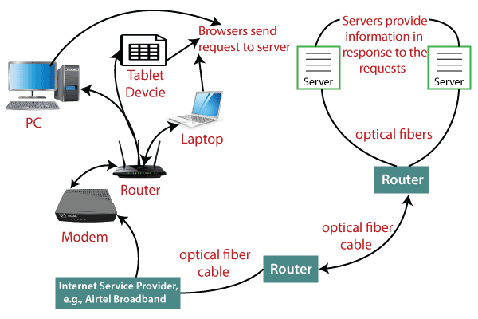**Now after understanding the basics, let us see how internet works?**

When you turn on your computer and type a domain name in the browser search bar, your browser sends a request to the DNS server to get the corresponding IP address. After getting the IP address, the browser forwards the request to the respective server.

Once the server gets the request to provide information about a particular website, the data starts flowing. The data is transferred through the optical fiber cables in digital format or in the form of light pulses. As the servers are placed at distant places, the data may have to travel thousands of miles through optical fiber cable to reach your computer.

The optical fiber is connected to a router, which converts the light signals into electrical signals. These electrical signals are transmitted to your laptop using an Ethernet cable. Thus, you receive the desired information through the internet, which is actually a cable that connects you with the server.

Furthermore, if you are using wireless internet using wifi or mobile data, the signals from the optical cable are first sent to a cell tower and from where it reaches to your cell phone in the form of electromagnetic waves.

The internet is managed by ICANN (Internet Corporation for Assigned Names and Numbers) located in the USA. It manages IP addresses assignment, [domain](https://www.javatpoint.com/what-is-domain) name registration, etc.

## **Uses of the internet**

* Using social media and content sharing.
* Instant messaging, video conferencing, Internet Relay Chat (IRC), Internet telephony, and email are all examples of electronic communication. These all are used through the Internet.
* Access to online degree programs, courses, and workshops for education and self-improvement.
* Searching for jobs: To advertise available positions, submit job applications, and hire candidates identified on social networking sites like LinkedIn, both employers and applicants use the Internet.

## **Difference between the World Wide Web and the Internet**

The World Wide Web (also known as the Web) and the Internet are fundamentally dissimilar from one another because the Web is a collection of information that can be accessed using the Internet, whereas the Internet is a global network of networks that offers access to almost all types of information. In other words, the Web is a service that was added to the Internet's foundation.

The Web is the part of the Internet that gets the greatest traffic. One unique aspect of this is hypertext, a rapid cross-referencing method. The majority of websites feature text that highlights keywords or phrases by being a different color than the rest of the text. When a user selects one of these words or phrases, they will be sent to the chosen website or page. Buttons, graphics, and even particular areas of images are also utilized as hyperlinks.

On the Internet, there are billions of pages of information. The most popular web browsers are Google Chrome, Firefox, and Internet Explorer. A web browser is used to surf the internet or do online browsing. A certain Web site's look may vary slightly depending on the browser being used. A certain browser's later or more updated versions have the potential to render more complicated features like music files, sound, animation, and virtual reality.

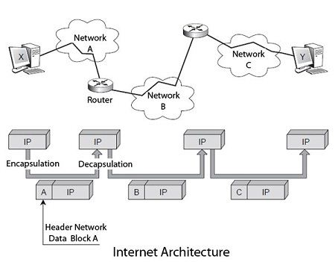

# Functions of the internet

### 1. Communications

### 2. Transactions

### 3. Getting information

### 4. Entertainment

Services of Internet

What is World Wide Web?

World Wide Web, which is also known as a Web, is a collection of websites or web pages stored in web servers and connected to local computers through the internet. These websites contain text pages, digital images, audios, videos, etc. Users can access the content of these sites from any part of the world over the internet using their devices such as computers, laptops, cell phones, etc. The WWW, along with internet, enables the retrieval and display of text and media to your device.

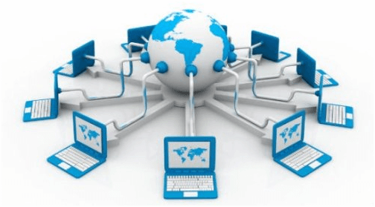

The building blocks of the Web are web pages which are formatted in HTML and connected by links called "hypertext" or hyperlinks and accessed by HTTP. These links are electronic connections that link related pieces of information so that users can access the desired information quickly. Hypertext offers the advantage to select a word or phrase from text and thus to access other pages that provide additional information related to that word or phrase.

A web page is given an online address called a Uniform Resource Locator (URL). A particular collection of web pages that belong to a specific URL is called a website, e.g., *www.facebook.com*, *www.google.com*, etc. So, the World Wide Web is like a huge electronic book whose pages are stored on multiple servers across the world.

Small websites store all of their Web Pages on a single server, but big websites or organizations place their Web Pages on different servers in different countries so that when users of a country search their site they could get the information quickly from the nearest server.

## **How the World Wide Web Works?**

Now, we have understood that WWW is a collection of websites connected to the internet so that people can search and share information. Now, let us understand how it works!

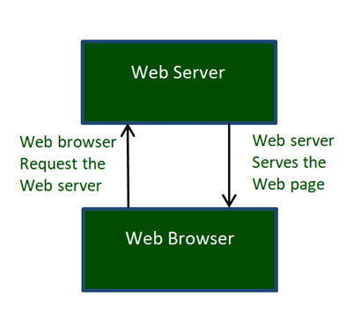

The Web works as per the internet's basic client-server format as shown in the following image. The servers store and transfer web pages or information to user's computers on the network when requested by the users. A web server is a software program which serves the web pages requested by web users using a browser. The computer of a user who requests documents from a server is known as a client. Browser, which is installed on the user' computer, allows users to view the retrieved documents.

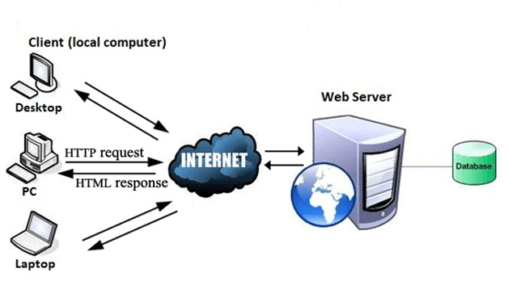

All the websites are stored in web servers. Just as someone lives on rent in a house, a website occupies a space in a server and remains stored in it. The server hosts the website whenever a user requests its WebPages, and the website owner has to pay the hosting price for the same.

The moment you open the browser and type a URL in the address bar or search something on Google, the WWW starts working. There are three main technologies involved in transferring information (web pages) from servers to clients (computers of users). These technologies include Hypertext Markup Language (HTML), Hypertext Transfer Protocol (HTTP) and Web browsers.

# FTP

* FTP stands for File transfer protocol.
* FTP is a standard internet protocol provided by TCP/IP used for transmitting the files from one host to another.
* It is mainly used for transferring the web page files from their creator to the computer that acts as a server for other computers on the internet.
* It is also used for downloading the files to computer from other servers.

## **Objectives of FTP**

* It provides the sharing of files.
* It is used to encourage the use of remote computers.
* It transfers the data more reliably and efficiently.

## **Mechanism of FTP**

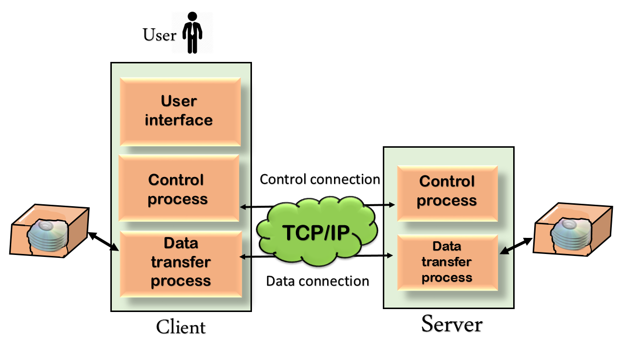

The above figure shows the basic model of the FTP. The FTP client has three components: the user interface, control process, and data transfer process. The server has two components: the server control process and the server data transfer process.

**There are two types of connections in FTP:**

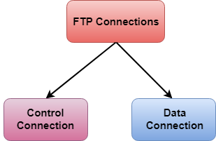

* **Control Connection:** The control connection uses very simple rules for communication. Through control connection, we can transfer a line of command or line of response at a time. The control connection is made between the control processes. The control connection remains connected during the entire interactive FTP session.
* **Data Connection:** The Data Connection uses very complex rules as data types may vary. The data connection is made between data transfer processes. The data connection opens when a command comes for transferring the files and closes when the file is transferred.

## **FTP Clients**

* FTP client is a program that implements a file transfer protocol which allows you to transfer files between two hosts on the internet.
* It allows a user to connect to a remote host and upload or download the files.
* It has a set of commands that we can use to connect to a host, transfer the files between you and your host and close the connection.
* The FTP program is also available as a built-in component in a Web browser. This GUI based FTP client makes the file transfer very easy and also does not require to remember the FTP commands.

### **Advantages of FTP:**

* **Speed:** One of the biggest advantages of FTP is speed. The FTP is one of the fastest way to transfer the files from one computer to another computer.
* **Efficient:** It is more efficient as we do not need to complete all the operations to get the entire file.
* **Security:** To access the FTP server, we need to login with the username and password. Therefore, we can say that FTP is more secure.
* **Back & forth movement:** FTP allows us to transfer the files back and forth. Suppose you are a manager of the company, you send some information to all the employees, and they all send information back on the same server.

### **Disadvantages of FTP:**

* The standard requirement of the industry is that all the FTP transmissions should be encrypted. However, not all the FTP providers are equal and not all the providers offer encryption. So, we will have to look out for the FTP providers that provides encryption.
* FTP serves two operations, i.e., to send and receive large files on a network. However, the size limit of the file is 2GB that can be sent. It also doesn't allow you to run simultaneous transfers to multiple receivers.
* Passwords and file contents are sent in clear text that allows unwanted eavesdropping. So, it is quite possible that attackers can carry out the brute force attack by trying to guess the FTP password.
* It is not compatible with every system.

# Telnet

* The main task of the internet is to provide services to users. For example, users want to run different application programs at the remote site and transfers a result to the local site. This requires a client-server program such as FTP, SMTP. But this would not allow us to create a specific program for each demand.
* The better solution is to provide a general client-server program that lets the user access any application program on a remote computer. Therefore, a program that allows a user to log on to a remote computer. A popular client-server program Telnet is used to meet such demands. Telnet is an abbreviation for **Terminal Network**.
* Telnet provides a connection to the remote computer in such a way that a local terminal appears to be at the remote side.

## **There are two types of login:**

### **Local Login**

### Computer Network Telnet

### When a user logs into a local computer, then it is known as local login.

### When the workstation running terminal emulator, the keystrokes entered by the user are accepted by the terminal driver. The terminal driver then passes these characters to the operating system which in turn, invokes the desired application program.

### However, the operating system has special meaning to special characters. For example, in UNIX some combination of characters have special meanings such as control character with "z" means suspend. Such situations do not create any problem as the terminal driver knows the meaning of such characters. But, it can cause the problems in remote login.

### **Remote login**

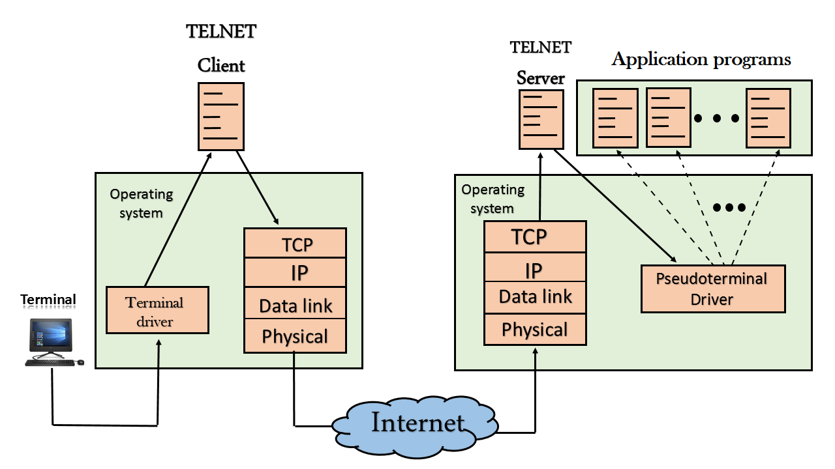

* + When the user wants to access an application program on a remote computer, then the user must perform remote login.

## **How remote login occurs**

### **At the local site**

The user sends the keystrokes to the terminal driver, the characters are then sent to the TELNET client. The TELNET client which in turn, transforms the characters to a universal character set known as network virtual terminal characters and delivers them to the local TCP/IP stack

# SMTP

* SMTP stands for Simple Mail Transfer Protocol.
* SMTP is a set of communication guidelines that allow software to transmit an electronic mail over the internet is called **Simple Mail Transfer Protocol**.
* It is a program used for sending messages to other computer users based on e-mail addresses.
* It provides a mail exchange between users on the same or different computers, and it also supports:
  + It can send a single message to one or more recipients.
  + Sending message can include text, voice, video or graphics.
  + It can also send the messages on networks outside the internet.
* The main purpose of SMTP is used to set up communication rules between servers. The servers have a way of identifying themselves and announcing what kind of communication they are trying to perform. They also have a way of handling the errors such as incorrect email address. For example, if the recipient address is wrong, then receiving server reply with an error message of some kind.

## **Components of SMTP**

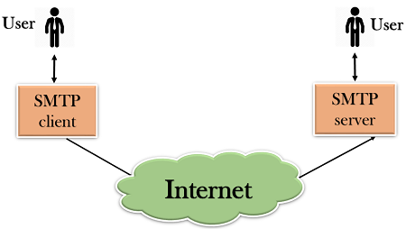

* First, we will break the SMTP client and SMTP server into two components such as user agent (UA) and mail transfer agent (MTA). The user agent (UA) prepares the message, creates the envelope and then puts the message in the envelope. The mail transfer agent (MTA) transfers this mail across the internet.

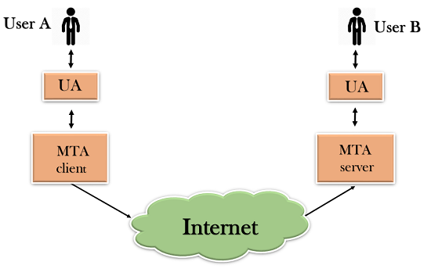

* SMTP allows a more complex system by adding a relaying system. Instead of just having one MTA at sending side and one at receiving side, more MTAs can be added, acting either as a client or server to relay the email.

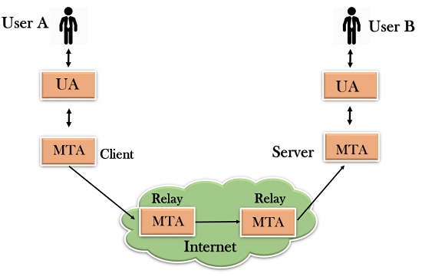

* The relaying system without TCP/IP protocol can also be used to send the emails to users, and this is achieved by the use of the mail gateway. The mail gateway is a relay MTA that can be used to receive an email.

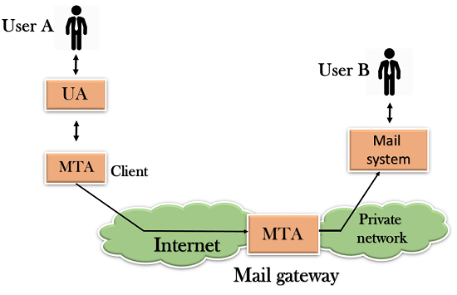

## **Working of SMTP**

1. **Composition of Mail:** A user sends an e-mail by composing an electronic mail message using a Mail User Agent (MUA). Mail User Agent is a program which is used to send and receive mail. The message contains two parts: body and header. The body is the main part of the message while the header includes information such as the sender and recipient address. The header also includes descriptive information such as the subject of the message. In this case, the message body is like a letter and header is like an envelope that contains the recipient's address.
2. **Submission of Mail:** After composing an email, the mail client then submits the completed e-mail to the SMTP server by using SMTP on TCP port 25.
3. **Delivery of Mail:** E-mail addresses contain two parts: username of the recipient and domain name. For example, vivek@gmail.com, where "vivek" is the username of the recipient and "gmail.com" is the domain name.  
   If the domain name of the recipient's email address is different from the sender's domain name, then MSA will send the mail to the Mail Transfer Agent (MTA). To relay the email, the MTA will find the target domain. It checks the MX record from Domain Name System to obtain the target domain. The MX record contains the domain name and IP address of the recipient's domain. Once the record is located, MTA connects to the exchange server to relay the message.
4. **Receipt and Processing of Mail:** Once the incoming message is received, the exchange server delivers it to the incoming server (Mail Delivery Agent) which stores the e-mail where it waits for the user to retrieve it.
5. **Access and Retrieval of Mail:** The stored email in MDA can be retrieved by using MUA (Mail User Agent). MUA can be accessed by using login and password.

# Gopher

Gopher is a communications protocol designed for distributing, searching, and retrieving documents over LAN or over the internet. It is designed to be a menu-driven alternative to the early web but has been less popular that using the web browser to view HTTP content. Every gopher page is designed to be like a directory on a hard drive or the results page of a search engine, it has a bunch of links and explanations as what each link is so you can get closer to finding the page that has the information that you want. Gopher is a communications protocol aimed at competing with HTTP for its place as the main protocol of the internet. Released in 1991 Gopher was initially quite popular but never quite caught on to the extent that HTTP did partly thanks to the University of Minnesota, which owned the rights, deciding to charge a license fee for using their gopher server implementation.  
Gopher has four central goals:

A file-like hierarchical arrangement that would be familiar to users.  
A simple syntax.  
A system that can be created quickly and inexpensively.  
Extending the file system metaphor, such as searches.

### **Common Uses of Gopher**

* The Internet Gopher protocol is designed for distributed document search and retrieval.
* Gopher has a more rigid structure than the free-form HTML of the Web.
* A Gopher system consists of a series of hierarchical hyperlinkable menus.

# Search Engines

A search engine is an **online answering machine**, which is used to search, understand, and organize content's result in its database based on the search query (keywords) inserted by the end-users (internet user). To display search results, all search engines first find the valuable result from their database, sort them to make an ordered list based on the search algorithm, and display in front of end-users. The process of organizing content in the form of a list is commonly known as a **Search Engine Results Page (SERP)**.

**Google**, **Yahoo!, Bing**, **YouTube**, and **DuckDuckGo** are some popular examples of search engines.

## **Advantages of Search Engine**

Searching content on the Internet becomes one of the most popular activities all over the world. In the current era, the search engine is an essential part of everyone's life because the search engine offers various popular ways to find valuable, relevant, and informative content on the Internet.

A list of advantages of search engines is given below -

### **1. Time-Saving**

Search engine helps us to save time by the following two ways -

* Eliminate the need to find information manually.
* Perform search operations at a very high speed.

### **2. Variety of information**

The search engine offers various variety of resources to obtain relevant and valuable information from the Internet. By using a search engine, we can get information in various fields such as education, entertainment, games, etc. The information which we get from the search engine is in the form of blogs, pdf, ppt, text, images, videos, and audios.

### **3. Precision**

All search engines have the ability to provide more precise results.

### **4. Free Access**

Mostly search engines such as Google, Bing, and Yahoo allow end-users to search their content for free. In search engines, there is no restriction related to a number of searches, so all end users (Students, Job seekers, IT employees, and others) spend a lot of time to search valuable content to fulfill their requirements.

### **5. Advanced Search**

Search engines allow us to use advanced search options to get relevant, valuable, and informative results. Advanced search results make our searches more flexible as well as sophisticated. For example, when you want to search for a specific site, type **"site:"** without quotes followed by the site's web address.

Suppose we want to search for java tutorial on ABCD then type **"java site:www.ABCD.com"** to get the advanced result quickly.

To search about education institution sites (colleges and universities) for B.Tech in computer science engineering, then use **"computer science engineering site:.edu."** to get the advanced result.

### **6. Relevance**

Search engines allow us to search for relevant content based on a particular keyword. For example, a site "ABCD" scores a higher search for the term "java tutorial" this is because a search engine sorts its result pages by the relevance of the content; that's why we can see the highest-scoring results at the top of SERP.

## **Disadvantages of Search Engine**

There are the following disadvantages of Search Engines -

* Sometimes the search engine takes too much time to display relevant, valuable, and informative content.
* Search engines, especially Google, frequently update their algorithm, and it is very difficult to find the algorithm in which Google runs.
* It makes end-users effortless as they all time use search engines to solve their small queries also.

## **Components of Search Engine**

There are the following four basic components of Search Engine -

### **1. Web Crawler**

Web Crawler is also known as a **search engine bot**, **web robot**, or **web spider**. It plays an essential role in search engine optimization (SEO) strategy. It is mainly a software component that traverses on the web, then downloads and collects all the information over the Internet.

There are the following web crawler features that can affect the search results –

* Included Pages
* Excluded Pages
* Document Types
* Frequency of Crawling

### **2. Database**

The search engine database is a type of **Non-relational database**. It is the place where all the web information is stored. It has a large number of web resources. Some most popular search engine databases are **Amazon Elastic Search Service** and **Splunk**.

There are the following two database variable features that can affect the search results:

* Size of the database
* The freshness of the database

### **3. Search Interfaces**

Search Interface is one of the most important components of Search Engine. It is an interface between the user and the database. It basically helps users to search for queries using the database.

There are the following features Search Interfaces that affect the search results -

* Operators
* Phrase Searching
* Truncation

### **4. Ranking Algorithms**

The ranking algorithm is used by Google to rank web pages according to the Google search algorithm.

There are the following ranking features that affect the search results -

* Location and frequency
* Link Analysis
* Clickthrough measurement

## **How do search engines work**

There are the following tasks done by every search engines -

### **1. Crawling**

Crawling is the first stage in which a search engine uses web crawlers to find, visit, and download the web pages on the WWW (World Wide Web). Crawling is performed by software robots, known as "**spiders**" or "**crawlers**." These robots are used to review the website content.

### **2. Indexing**

Indexing is an online library of websites, which is used to sort, store, and organize the content that we found during the crawling. Once a page is indexed, it appears as a result of the most valuable and most relevant query.

### **3. Ranking and Retrieval**

The ranking is the last stage of the search engine. It is used to provide a piece of content that will be the best answer based on the user's query. It displays the best content at the top rank of the website.

## **Search Engine Processing**

There are following two major Search Engine processing functions -

### **1. Indexing process**

Indexing is the process of building a structure that enables searching.

Indexing process contains the following three blocks -

**i. Text acquisition**

It is used to identify and store documents for indexing.

**ii. Text transformation**

It is the process of transform documents into index or features.

**iii. Index creation**

Index creation takes the output from text transformation and creates the indexes or data searches that enable fast searching.

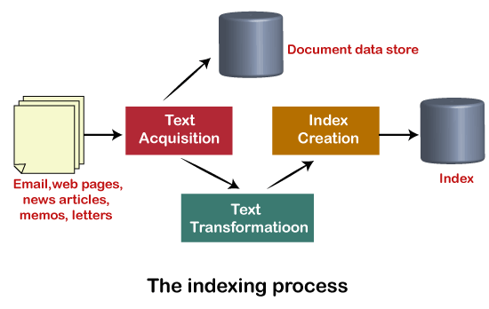

What is E-mail?



E-mail is defined as the transmission of messages on the Internet. It is one of the most commonly used features over communications networks that may contain text, files, images, or other attachments. Generally, it is information that is stored on a computer sent through a network to a specified individual or group of individuals.

Email messages are conveyed through email servers; it uses multiple protocols within the [TCP/IP](https://www.javatpoint.com/tcp-ip-full-form) suite. For example, [SMTP is a protocol](https://www.javatpoint.com/simple-mail-transfer-protocol), stands for [simple mail transfer protocol](https://www.javatpoint.com/smtp-full-form) and used to send messages whereas other protocols IMAP or POP are used to retrieve messages from a mail server. If you want to login to your mail account, you just need to enter a valid email address, password, and the mail servers used to send and receive messages.

Although most of the webmail servers automatically configure your mail account, therefore, you only required to enter your email address and password. However, you may need to manually configure each account if you use an email client like Microsoft Outlook or Apple Mail. In addition, to enter the email address and password, you may also need to enter incoming and outgoing mail servers and the correct port numbers for each one.

Email messages include three components, which are as follows:

* **Message envelope:** It depicts the email's electronic format.
* **Message header:** It contains email subject line and sender/recipient information.
* **Message body:** It comprises images, text, and other file attachments.

The email was developed to support rich text with custom formatting, and the original email standard is only capable of supporting plain text messages. In modern times, email supports [HTML](https://www.javatpoint.com/html-tutorial) (Hypertext markup language), which makes it capable of emails to support the same formatting as [websites](https://www.javatpoint.com/website). The email that supports HTML can contain links, images, [CSS layouts](https://www.javatpoint.com/css-layout), and also can send files or "email attachments" along with messages. Most of the mail servers enable users to send several attachments with each message. The attachments were typically limited to one megabyte in the early days of email. Still, nowadays, many mail servers are able to support email attachments of 20 megabytes or more in size.

## **Advantages of Email**

There are many advantages of email, which are as follows:

* **Cost-effective:** Email is a very cost-effective service to communicate with others as there are several email services available to individuals and organizations for free of cost. Once a user is online, it does not include any additional charge for the services.
* Email offers users the benefit of accessing email from anywhere at any time if they have an Internet connection.
* Email offers you an incurable communication process, which enables you to send a response at a convenient time. Also, it offers users a better option to communicate easily regardless of different schedules users.
* **Speed and simplicity:** Email can be composed very easily with the correct information and contacts. Also, minimum lag time, it can be exchanged quickly.
* **Mass sending:** You can send a message easily to large numbers of people through email.
* Email exchanges can be saved for future retrieval, which allows users to keep important conversations or confirmations in their records and can be searched and retrieved when they needed quickly.
* Email provides a simple user interface and enables users to categorize and filter their messages. This can help you recognize unwanted emails like junk and spam mail. Also, users can find specific messages easily when they are needed.
* As compared to traditional posts, emails are delivered extremely fast.
* Email is beneficial for the planet, as it is paperless. It reduces the cost of paper and helps to save the environment by reducing paper usage.
* It also offers a benefit to attaching the original message at the time you reply to an email. This is beneficial when you get hundreds of emails a day, and the recipient knows what you are talking about.
* Furthermore, emails are beneficial for advertising products. As email is a form of communication, organizations or companies can interact with a lot of people and inform them in a short time

## **Disadvantages of Email**

* **Impersonal:** As compared to other forms of communication, emails are less personal. For example, when you talk to anyone over the phone or meeting face to face is more appropriate for communicating than email.
* **Misunderstandings:** As email includes only text, and there is no tone of voice or body language to provide context. Therefore, misunderstandings can occur easily with email. If someone sends a joke on email, it can be taken seriously. Also, well-meaning information can be quickly typed as rude or aggressive that can impact wrong. Additionally, if someone types with short abbreviations and descriptions to send content on the email, it can easily be misinterpreted.
* **Malicious Use:** As email can be sent by anyone if they have an only email address. Sometimes, an unauthorized person can send you mail, which can be harmful in terms of stealing your personal information. Thus, they can also use email to spread gossip or false information.
* **Accidents Will Happen:** With email, you can make fatal mistakes by clicking the wrong button in a hurry. For instance, instead of sending it to a single person, you can accidentally send sensitive information to a large group of people. Thus, the information can be disclosed, when you have clicked the wrong name in an address list. Therefore, it can be harmful and generate big trouble in the workplace.
* **Spam:** Although in recent days, the features of email have been improved, there are still big issues with unsolicited advertising arriving and spam through email. It can easily become overwhelming and takes time and energy to control.
* **Information Overload:** As it is very easy to send email to many people at a time, which can create information overload. In many modern workplaces, it is a major problem where it is required to move a lot of information and impossible to tell if an email is important. And, email needs organization and upkeep. The bad feeling is one of the other problems with email when you returned from vacation and found hundreds of unopened emails in your inbox.
* **Viruses:** Although there are many ways to travel viruses in the devices, email is one of the common ways to enter viruses and infect devices. Sometimes when you get a mail, it might be the virus come with an attached document. And, the virus can infect the system when you click on the email and open the attached link. Furthermore, an anonymous person or a trusted friend or contact can send infected emails.
* **Pressure to Respond:** If you get emails and you do not answer them, the sender can get annoyed and think you are ignoring them. Thus, this can be a reason to make pressure on your put to keep opening emails and then respond in some way.
* **Time Consuming:** When you get an email and read, write, and respond to emails that can take up vast amounts of time and energy. Many modern workers spend their most time with emails, which may be caused to take more time to complete work.
* **Overlong Messages:** Generally, email is a source of communication with the intention of brief messages. There are some people who write overlong messages that can take much time than required.
* **Insecure:** There are many hackers available that want to gain your important information, so email is a common source to seek sensitive data, such as political, financial, documents, or personal messages. In recent times, there have various high-profile cases occurred that shown how email is insecure about information theft.

## **Different types of Email**

There are many types of email; such are as follows:

**Newsletters:** It is studying by Clutch, the newsletter is the most common type of email that are routinely sent to all mailing list subscribers, either daily, weekly, or monthly. These emails often contain from the blog or website, links curated from other sources, and selected content that the company has recently published. Typically, Newsletter emails are sent on a consistent schedule, and they offer businesses the option to convey important information to their client through a single source. Newsletters might also incorporate upcoming events or new, webinars from the company, or other updates.

**Lead Nurturing:** Lead-nurturing emails are a series of related emails that marketers use to take users on a journey that may impact their buying behavior. These emails are typically sent over a period of several days or weeks. Lead-nurturing emails are also known as trigger campaigns, which are used for solutions in an attempt to move any prospective sale into a completed purchase and educate potential buyers on the services. These emails are not only helpful for converting emails but also drive engagement. Furthermore, lead-nurturing emails are initiated by a potential buyer taking initial action, such as clicking links on a promotional email or downloading a free sample.

**Promotional emails:** It is the most common type of B2B (Business to Business) email, which is used to inform the email list of your new or existing products or services. These types of emails contain creating new or repeat customers, speeding up the buying process, or encouraging contacts to take some type of action. It provides some critical benefits to buyers, such as a free month of service, reduced or omitted fees for managed services, or percentage off the purchase price.

**Standalone Emails:** These emails are popular like newsletters emails, but they contain a limitation. If you want to send an email with multiple links or blurbs, your main call-to-action can weaken. Your subscriber may skip your email and move on, as they may click on the first link or two in your email but may not come back to the others.

**Onboarding emails:** An onboarding email is a message that is used to strengthen customer loyalty, also known as post-sale emails. These emails receive users right after subscription. The onboarding emails are sent to buyers to familiarize and educate them about how to use a product effectively. Additionally, when clients faced with large-scale service deployments, these emails help them facilitate user adoption.

**Transactional:** These emails are related to account activity or a commercial transaction and sent from one sender to one recipient. Some examples of transactional email are purchase confirmations, password reminder emails, and personalized product notifications. These emails are used when you have any kind of e-commerce component to your business. As compared to any other type of email, the transactional email messages have 8x the opens and clicks.

**Plain-Text Emails:** It is a simple email that does not include images or graphics and no formatting; it only contains the text. These types of emails may worth it if you try to only ever send fancy formatted emails, text-only messages. According to HubSpot, although people prefer fully designed emails with various images, plain text emails with less HTML won out in every A/B test. In fact, [HTML](https://www.javatpoint.com/html-tutorial) emails contain lower open and click-through rates, and plain text emails can be great for blog content, event invitations, and survey or feedback requests. Even if you do not send plainer emails, but you can boost your open and click through rates by simplifying your emails and including fewer images.

**Welcome emails:** It is a type of B2B email and common parts of onboarding emails that help users get acquainted with the brand. These emails can improve subscriber constancy as they include additional information, which helps to the new subscriber in terms of a business objective. Generally, welcome emails are sent buyers who got a subscription to a business's opt-in activities, such as a blog, mailing list, or webinar. Also, these emails can help businesses to build a better relationship between customers.

# What is a Browser?

A browser is a software program that is used to explore, retrieve, and display the information available on the World Wide Web. This information may be in the form of pictures, web pages, videos, and other files that all are connected via hyperlinks and categorized with the help of URLs (Uniform Resource Identifiers). For example, you are viewing this page by using a browser.

A browser is a client program as it runs on a user computer or mobile device and contacts the webserver for the information requested by the user. The web server sends the data back to the browser that displays the results on internet supported devices. On behalf of the users, the browser sends requests to web servers all over the internet by using [HTTP](https://www.javatpoint.com/http-full-form) (Hypertext Transfer Protocol). A browser requires a smartphone, computer, or tablet and internet to work.

### **History of Web Browser**

* The **WorldWideWeb** was the first web browser. It was created by W3C Director Tim Berners-Lee in **1990**. Later, it was renamed **Nexus** to avoid confusion caused by the actual World Wide Web.
* The **Lynx** browser was a text-based browser, which was invented in **1992**. It was not able to display the graphical content.
* Although, the first graphical user interface browser was NCSA Mosaic. It was the first most popular browser in the world, which was introduced in **1993**.
* In **1994**, there were some improvements occurred in Mosaic and came to Netscape Navigator.
* In **1995,**Microsoft introduced the **Internet Explorer** It was the first web browser developed by Microsoft.
* A research project started on Opera in **1994**. Later, it was publicly introduced in 1996.
* **Apple's Safari** browser was introduced in **2003**. It was specifically released for Macintosh computers.
* In **2004**, Mozilla introduced **Firefox** as Netscape Navigator.
* In **2007**, a browser **Mobile Safari** was released as Apple mobile web browser.
* The popular browser **Google Chrome** was launched in **2008**.
* The fast-growing mobile-based browser **Opera Mini** was released in **2011**.
* The Microsoft **Edge** browser was launched in **2015**.

### **Features of Web Browser**

Most Web browsers offer common features such as:

1. **Refresh button:** Refresh button allows the website to reload the contents of the web pages. Most of the web browsers store local copies of visited pages to enhance the performance by using a caching mechanism. Sometimes, it stops you from seeing the updated information; in this case, by clicking on the refresh button, you can see the updated information.
2. **Stop button:** It is used to cancel the communication of the web browser with the server and stops loading the page content. For example, if any malicious site enters the browser accidentally, it helps to save from it by clicking on the stop button.
3. **Home button:** It provides users the option to bring up the predefined home page of the website.
4. **Web address bar:** It allows the users to enter a web address in the address bar and visit the website.
5. **Tabbed browsing:** It provides users the option to open multiple websites on a single window. It helps users to read different websites at the same time. For example, when you search for anything on the browser, it provides you a list of search results for your query. You can open all the results by right-clicking on each link, staying on the same page.
6. **Bookmarks:** It allows the users to select particular website to save it for the later retrieval of information, which is predefined by the users.

### **What is the URL (Uniform Resource Locator)?**

A **uniform resource locator** is the address of a resource on the internet or the [World Wide Web](https://www.javatpoint.com/what-is-world-wide-web). It is also known as a web address or uniform resource identifier (URI). For example, **https: www.** [ABCD](https://www.javatpoint.com/)**.com**, which is the URL or web address for the [ABCD](https://www.javatpoint.com/) website. A [URL](https://www.javatpoint.com/url-full-form) represents the address of a resource, including the protocol used to access it.

* A URL includes the following information: It uses the protocol to access the resource.
* It defines the location of a server by IP address or the domain name.
* It includes a fragment identifier, which is optional.
* It contains the location of the resource in the directory of the server.

A URL forwards user to a particular online resource, such as a video, webpage, or other resources. For example, when you search information on Google, the search results display the URL of the relevant resources in response to your search query. The title which appears in the search results is a hyperlink of the URL of the webpage. It is a **Uniform Resource Identifier**, which refers to all kinds of names and addresses of the resources on the webservers. URL's first part is known as a **protocol identifier**, and it specifies the protocol to use, and the second part, which is known as a resource name, represents the [IP](https://www.javatpoint.com/ip-full-form) address or the domain name of a resource. Both parts are differentiated by a colon and two forward

### **Component of a Web browser**

The primary components of a browser are shown in the below image:

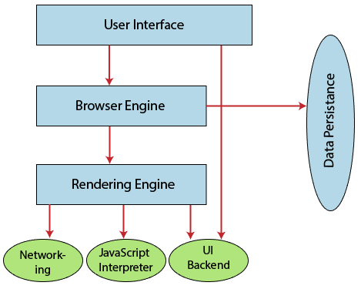

1. **User Interface:** The user interface is an area where the user can use several options like address bar, back and forward button, menu, bookmarking, and many other options to interact with the browser.
2. **Browser Engine:** It connects the UI (User Interface) and the rendering engine as a bridge. It queries and manipulates the rendering engine based on inputs from several user interfaces.
3. **Rendering Engine:** It is responsible for displaying the requested content on the browser screen. It translates the HTML, XML files, and images, which are formatted by using the CSS. It generates the layout of the content and displays it on the browser screen. Although it can also display the other types of content by using different types of plugins or extensions. such as:
   * Internet Explorer uses **Trident**
   * Chrome & Opera 15+ use **Blink**
   * Chrome (iPhone) & Safari use **Webkit**
   * Firefox & other Mozilla browsers use **Gecko**
4. **Networking:** It retrieves the URLs by using internet protocols like HTTP or FTP. It is responsible for maintaining all aspects of Internet communication and security. Furthermore, it may be used to cache a retrieved document to reduce network traffic.
5. **JavaScript Interpreter:** As the name suggests, JavaScript Interpreter translates and executes the JavaScript code, which is included in a website. The translated results are sent to the rendering engine to display results on the device screen.
6. **UI Backend:** It is used to draw basic combo boxes and Windows (widgets). It specifies a generic interface, which is not platform-specific.
7. **Data Storage:** The data storage is a persistence layer that is used by the browser to store all sorts of information locally, like cookies. A browser also supports different storage mechanisms such as IndexedDB, WebSQL, localStorage, and FileSystem. It is a database stored on the local drive of your computer where the browser is installed. It handles user data like cache, bookmarks, cookies, and preferences.

### **List of Internet Browsers**

**Microsoft Edge**

**Amazon Silk**

**Opera**

**Apple Safari**

**Google Chrome**

**Mozilla Firefox**

**Internet Explorer**

## **What Is IoT:**

    IoT stands for Internet of Things. It refers to the interconnectedness of physical devices, such as appliances and vehicles, that are embedded with software, sensors, and connectivity which enables these objects to connect and exchange data. This technology allows for the collection and sharing of data from a vast network of devices, creating opportunities for more efficient and automated systems.

**Internet of Things (IoT)** is the networking of physical objects that contain electronics embedded within their architecture in order to communicate and sense interactions amongst each other or with respect to the external environment. In the upcoming years, IoT-based technology will offer advanced levels of services and practically change the way people lead their daily lives. Advancements in medicine, power, gene therapies, agriculture, smart cities, and smart homes are just a very few of the categorical examples where IoT is strongly established.

***IoT is network of interconnected computing devices which are embedded in everyday objects, enabling them to send and receive data.***

Over 9 billion ‘Things’ (physical objects) are currently connected to the Internet, as of now. In the near future, this number is expected to rise to a whopping 20 billion.

**Main components used in IoT:**

* **Low-power embedded systems:**Less battery consumption, high performance are the inverse factors that play a significant role during the design of electronic systems.
* **Sensors:**Sensors are the major part of any IoT application. It is a physical device that measures and detects certain physical quantities and converts it into signal which can be provided as an input to processing or control unit for analysis purpose.

**Different types of Sensors:**

1. Temperature Sensors
2. Image Sensors
3. Gyro Sensors
4. Obstacle Sensors
5. RF Sensor
6. IR Sensor
7. MQ-02/05 Gas Sensor
8. LDR Sensor
9. Ultrasonic Distance Sensor

* **Control Units:** It is a unit of small computer on a single integrated circuit containing microprocessor or processing core, memory and programmable input/output devices/peripherals. It is responsible for major processing work of IoT devices and all logical operations are carried out here.
* **Cloud computing:**Data collected through IoT devices is massive, and this data has to be stored on a reliable storage server. This is where cloud computing comes into play. The data is processed and learned, giving more room for us to discover where things like electrical faults/errors are within the system.
* **Availability of big data:**We know that IoT relies heavily on sensors, especially in real-time. As these electronic devices spread throughout every field, their usage is going to trigger a massive flux of big data.
* **Networking connection:**In order to communicate, internet connectivity is a must, where each physical object is represented by an IP address. However, there are only a limited number of addresses available according to the IP naming. Due to the growing number of devices, this naming system will not be feasible anymore. Therefore, researchers are looking for another alternative naming system to represent each physical object.

**There are two ways of building IoT:**

1. Form a separate internet work including only physical objects.
2. Make the Internet ever more expansive, but this requires hard-core technologies such as rigorous cloud computing and rapid big data storage (expensive).

In the near future, IoT will become broader and more complex in terms of scope. It will change the world in terms of 

*“anytime, anyplace, anything in connectivity.”*

**IoT Enablers:**

* **RFIDs:** uses radio waves in order to electronically track the tags attached to each physical object.
* **Sensors:** devices that are able to detect changes in an environment (ex: motion detectors).
* **Nanotechnology:** as the name suggests, these are tiny devices with dimensions usually less than a hundred nanometers.
* **Smart networks:** (ex: mesh topology).

**Working with IoT Devices:**

* *Collect and Transmit Data :*For this purpose sensors are widely used they are used as per requirements in different application areas.
* *Actuate device based on triggers produced by sensors or processing devices:*If certain conditions are satisfied or according to user’s requirements if certain trigger is activated then which action to perform that is shown by Actuator devices.
* *Receive Information:*From network devices, users or devices can take certain information also for their analysis and processing purposes*.*
* *Communication Assistance:*Communication assistance is the phenomenon of communication between 2 networks or communication between 2 or more IoT devices of same or different networks. This can be achieved by different communication protocols like: MQTT, Constrained Application Protocol, ZigBee, FTP, HTTP etc.

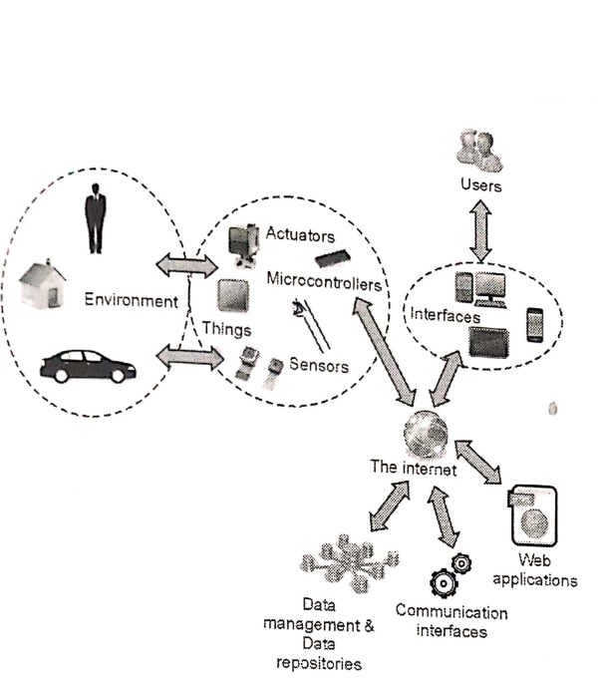*Working of IoT*

**Characteristics of IoT:**

* Massively scalable and efficient
* IP-based addressing will no longer be suitable in the upcoming future.
* An abundance of physical objects is present that do not use IP, so IoT is made possible.
* Devices typically consume less power. When not in use, they should be automatically programmed to sleep.
* A device that is connected to another device right now may not be connected in another instant of time.
* Intermittent connectivity – IoT devices aren’t always connected. In order to save bandwidth and battery consumption, devices will be powered off periodically when not in use. Otherwise, connections might turn unreliable and thus prove to be inefficient.

# IoT in Smart Home and Smart City Application

Implementing IoT system in home and city leads them to become as smart home and smart city. Smart home or smart city make life quite easier and smarter.

A **smart home system** can be something that makes our life quite easy. Starting from energy management where the power controls system in the AC appliances where we use the thermostat, all this is managed to cut down the power consumption that's taking place. A door management system, security management system, water management system are the part of this as well. Still, these are vital things that stand out in the smart home system. The limitation of IoT in smart home application stops where our imagination stops. Anything that we wish to automate or want to make our life easier can be a part of smart home, a smartphone system as well.

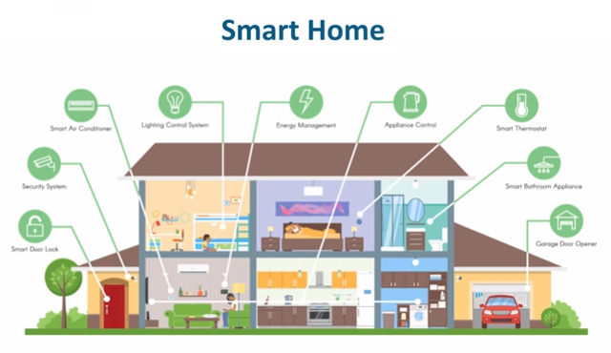

Now, a smart home usually is going to be a base of a **smart city**. The smart city is an evolution of a smart home. Here, it is not just the sensors of a single home that is connected, here its correlation or a network or a connection between various organizations, various domains as well as multiple segments of that city as a whole. In the smart city, the life of every single dependent becomes more comfortable and in tune really help to develop that city to greater extends as such. Now, the key factor for a smart city is government support as well, and if the governments are willing to take this step, then we hope we would see a smart city completely build on the Internet of Things.

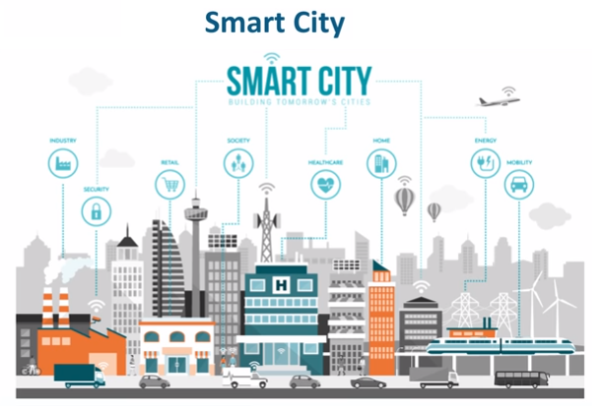

# Industrial Internet of Things (IIoT)

he industrial internet of things (IIoT) refers to the extension and use of the [internet of things](https://www.trendmicro.com/vinfo/us/security/definition/internet-of-things) (IoT) in industrial sectors and applications. With a strong focus on machine-to-machine (M2M) communication, [big data](https://www.trendmicro.com/vinfo/us/security/news/cybercrime-and-digital-threats/is-big-data-big-enough-for-machine-learning-in-cybersecurity), and [machine learning](https://www.trendmicro.com/vinfo/us/security/definition/machine-learning), the IIoT enables industries and enterprises to have better efficiency and reliability in their operations. The IIoT encompasses industrial applications, including robotics, medical devices, and software-defined production processes.

The IIoT goes beyond the normal consumer devices and internetworking of physical devices usually associated with the IoT. What makes it distinct is the intersection of information technology (IT) and operational technology (OT). OT refers to the networking of operational processes and [industrial control systems](https://www.trendmicro.com/vinfo/us/security/definition/industrial-control-system) (ICSs), including human machine interfaces (HMIs), supervisory control and data acquisition (SCADA) systems, distributed control systems (DCSs), and programmable logic controllers (PLCs).

The convergence of IT and OT provides industries with greater system integration in terms of automation and optimization, as well as better visibility of the supply chain and logistics. The monitoring and control of physical infrastructures in industrial operations, such as in agriculture, healthcare, manufacturing, transportation, and utilities, are made easier through the use of smart sensors and actuators as well as remote access and control.

### **What are the security considerations and challenges in adopting the IIoT?**

Adoption of the IIoT can revolutionize how industries operate, but there is the challenge of having strategies in place to boost digital transformation efforts while maintaining security amid increased connectivity.

Industries and enterprises that handle operational technologies can be expected to be well-versed in such aspects as worker safety and product quality. However, given that OT is being integrated into the internet, organizations are seeing the introduction of more intelligent and automated machines at work, which in turn invites a slew of new challenges that would require understanding of the IIoT’s inner workings.

With IIoT implementations, three areas need to be focused on: availability, scalability, and security. Availability and scalability may already be second nature to industrial operations, since they could already have been established or in the business for quite some time. Security, however, is where many can stumble when integrating the IIoT into their operations. For one thing, many businesses still use legacy systems and processes. Many of these have been in operation for decades and thus remain unaltered, thereby complicating the adoption of new technologies.

### **What are the risks to IIoT systems?**

Many security problems associated with the IIoT stem from a lack of basic security measures in place. Security gaps like exposed ports, inadequate authentication practices, and obsolete applications contribute to the emergence of risks. Combine these with having the network directly connected to the internet and more potential risks are invited.

Businesses may have grown familiar with the probable business impact of having IT systems go down because of cybercrime or malware infection. However, the convergence of IT and OT introduces a new significant risk factor: real-world threats that could affect even civilians.

Unsecure IIoT systems can lead to operational disruption and monetary loss, among other considerable consequences. More connected environments mean more security risks, such as:

* Software vulnerabilities that can be exploited to attack systems.
* [Publicly searchable](https://www.trendmicro.com/vinfo/us/security/news/internet-of-things/cities-exposed-in-shodan) internet-connected devices and systems.
* Malicious activities like hacking, targeted attacks, and data breaches.
* System manipulation that can cause operational disruption (e.g., product recalls) or sabotage processes (e.g., production line stoppage).
* System malfunction that can result in damage of devices and physical facilities or injury to operators or people nearby.
* OT systems held for extortion, as compromised through the IT environment.